The John D. Hodge Young Professional Award

AIAA Niagara Frontier Section
The AIAA Niagara Frontier Section is proud to name its Young Professional Award in honor of John Hodge, an engineer whose career reflects the aerospace heritage of our section in the United States and Canada.
Hodge launched his North American career at age 23 in Malton, Ontario, contributing to the groundbreaking Avro CF-105 Arrow program—one of the most advanced aircraft projects ever undertaken in Canada and a defining achievement within our section’s geographic footprint. After the Arrow’s cancellation, he brought his expertise to NASA, at age 34 becoming the second NASA flight director after Chris Kraft. He led the Blue Flight in Mission Control during Gordon Cooper’s record-breaking flight on Mercury-Atlas 9, and continued in that role during Project Gemini. His later work supported Apollo, Skylab, and long-range planning for the International Space Station, marking him as a leader whose influence spanned the formative decades of human spaceflight.
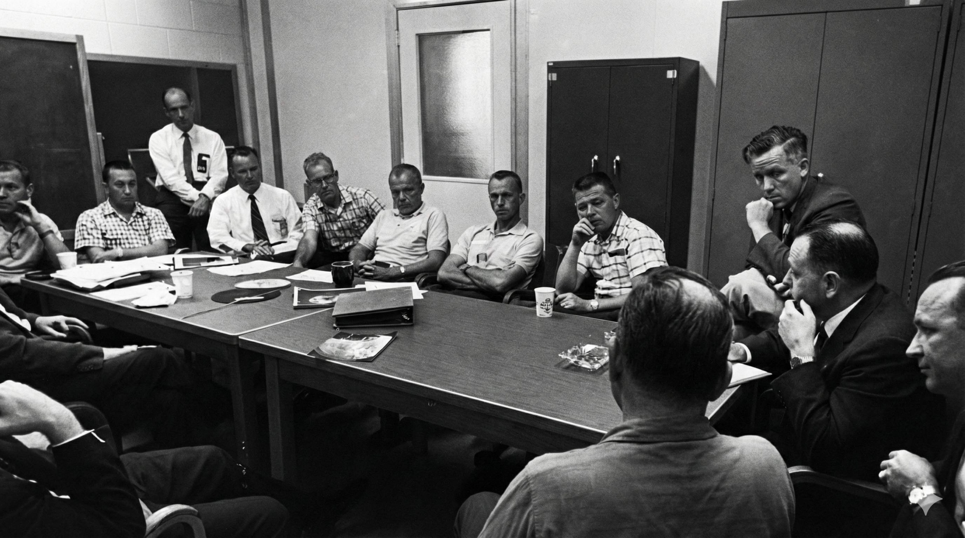
The John D. Hodge Young Professional Award honors early-career members of the Niagara Frontier Section who embody his spirit of innovation and technical excellence.
Mercury-Redstone 4 Mission Review Conference at Cape Canaveral in 1961. John Hodge, age 32, is on the right with his fist on his chin. Christopher Kraft is far right, John Glenn and Alan Shepard are on either side of the door, and Deke Slayton and Gus Grissom are on the far left.

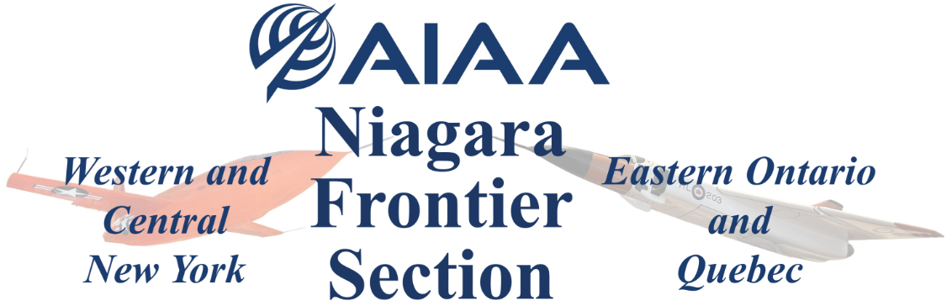
John D. Hodge Young Professional Award

The AIAA Niagara Frontier Section is proud to announce the renaming of our young professional award to the John Hodge Young Professional award. John D. Hodge (1929-2021) perfectly embodies this award and the spirit of the Niagara Frontier Section on both sides of the border. By the age of 35 Hodge made significant contributions to aerospace in Canada and the U.S., first with his work in Canada on the CF-105 Avro Arrow and then as NASA’s second flight director on Project Mercury after Chris Kraft.
This award honors a Young Professional for significant achievement within aeronautics and astronautics. The awardee shall be nominated by an AIAA member in good standing and selected by the NFS YP Award Committee, which consists of one voting representative from each state or province within the Niagara Frontier Section (New York, Ontario, Quebec) and the non-voting coordinator for the award nomination and selection. The awardee will be recognized with a plaque and two years of AIAA membership at the Niagara Frontier Aviation and Space Hall of Fame dinner and induction ceremony in May. The nominee is not required to be a member of AIAA.

Eligibility Requirements:
- The nominee must be age 35 or under on December 31 of the year preceding presentation.
- Resides and/or attends school in the AIAA Niagara Frontier Section.
  - Note, the Niagara Frontier Section includes all of New York west of Rome, NY, Ontario east of Sudbury, ON, and all of Quebec.
- The nominee is encouraged to show professional society participation such as serving as a committee member or officer, or providing support at society meetings or conferences.
- The nominee should show progress in professional experience and attainments, such as:
  - career advancement entailing increasing levels of responsibility,
  - recognition or citations for outstanding professional achievements,
  - continuing education in an engineering or related professional skill set, or
  - other professional attainments.
Scoring criteria:
- Professional/Educational achievements and awards (honors, publications, distinctions) 40%
- Professional background/experience including Society Affiliations 30%
- Education/Engineering Credentials (certifications) 20%
- Community involvement 10%

John D. Hodge Young Professional Award
Nomination Form

Please fill out this nomination form to submit a candidate for consideration.
Submit nomination forms to nf.aiaa.awards@gmail.com.
The deadline for nominations is 27 March 2026.

Nominee Information
Name

Email

Phone

Organization

Title

Education

Nominator Information
Name

Email

Phone

Professional/Educational achievements and awards (honors, publications, distinctions)
Professional background/experience including Society Affiliations
Education/Engineering Credentials (certifications)
Community involvement

